Residential Power Disaggregation

System Architecture Diagrams

Team Members:

Andrew Bailey, Ralph Cullom, Manny Harris, Labib Kasim

Sponsoring Entity:

ABB

Mentors:

Huangjie Gong

Date:

9/22/23

Table of Contents

**1. Project Background: 2**

Key Product Requirements: 2

Key features: 2

Key constraints: 2

**2. Product Concept Diagrams/Drawings: 3**

Concept Differences Table and Mockup Demo Preparation: 7

**3. User Operational Flow Chart: 7**

**4. System Functional Block Diagram: 8**

**5. Table of Trade-offs: 8**

**6. Design Challenges: 9**

**7. First Technical Milestone Preparation (“Hello World” demos): 9**

**8. Long-lead-time or critical items for purchasing: 10**

# Project Background:

Traditional household meters measure the combined consumption of all appliances, some of which possess substantial thermal mass and can be leveraged for demand response without compromising occupant comfort. To assess a residence's potential for demand response, a cost-effective, IoT-driven system could be employed by consumers to disaggregate various residential loads. This device will incorporate machine learning and advanced data processing techniques to break down and forecast residential load across different categories based on the aggregated measurement. The device will take total energy usage data from a standard meter, along with external weather data. The outcomes will encompass the computed energy usage for individual appliances/categories and their projections derived from the collective data gathered. This data can be used by homeowners to save money on their monthly power bill.

## Key Product Requirements:

### Key features:

* Device measures lumped power usage of a household.
* Data that the device collects should be sent wirelessly back to online data storage through IoT.
* Machine learning algorithms will take the data and weather as inputs and output the disaggregated loads.
* Machine learning algorithms will be able to predict future load usage.
* A centralized software system will record the past, present, and predicted future disaggregated loads.
* Mobile app or website so the customer can view their current and past energy usage.
* Display estimated usage for the future.

### Key constraints:

* Final cost of the product should be no more than $100.
* Device will be compatible with any 2.4GHz Wi-Fi service provider.
* Device shall be small enough to fit neatly inside the residential panel.
* Device should be compatible with a residential power source.

# Product Concept Diagrams/Drawings:

**Concept Drawings**

**Concept 1:**

| Key: **Existing Panel & Connections Our Device Notes** | |
| --- | --- |
| Front View of Panel | Device View |
| Current Transformer(CT) View |
|  | |

**Concept 2:**

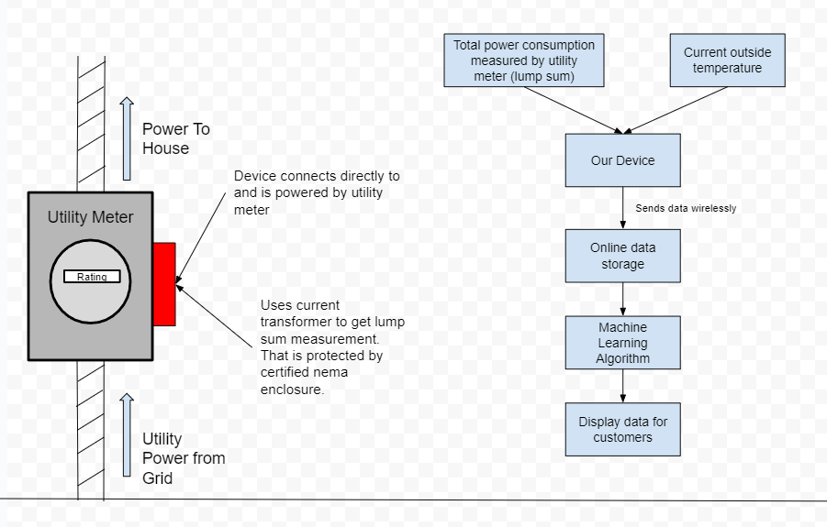

**Concept 3:**

**Panel view**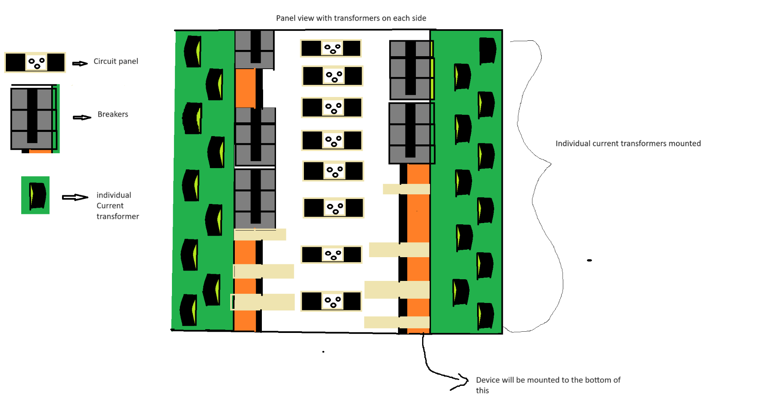

**Device view**

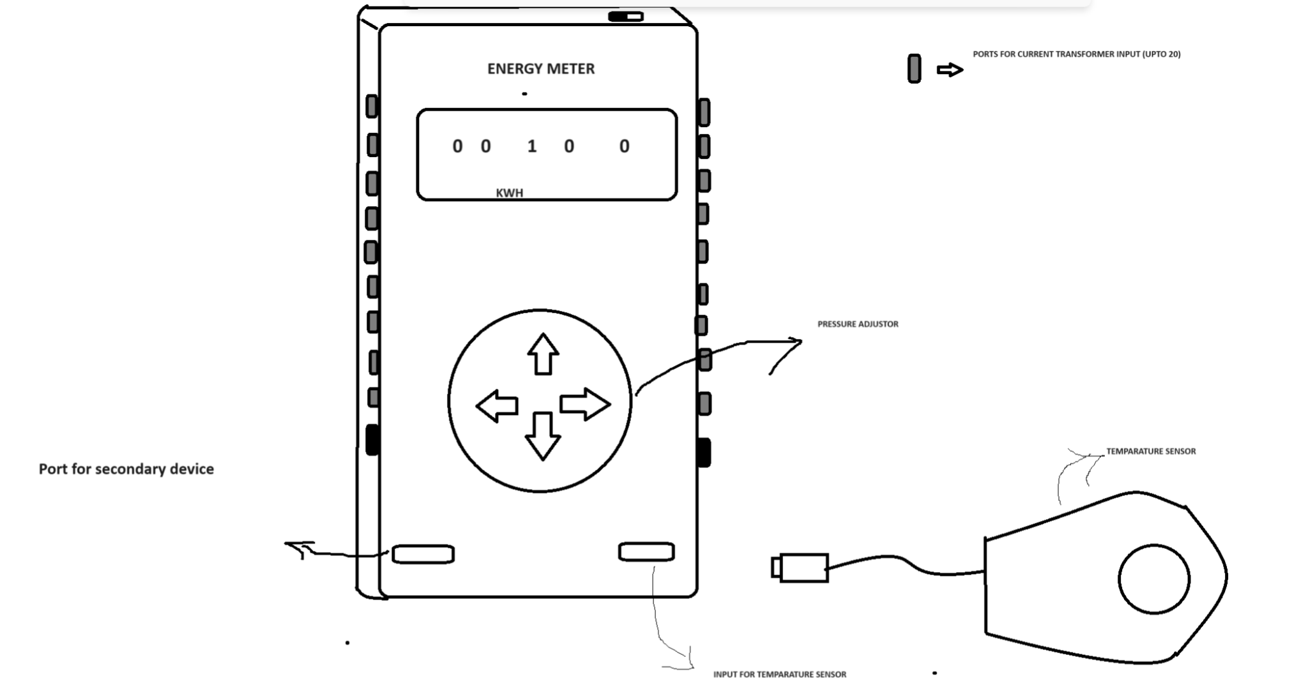

**Flow diagram**



**Concept 4:**

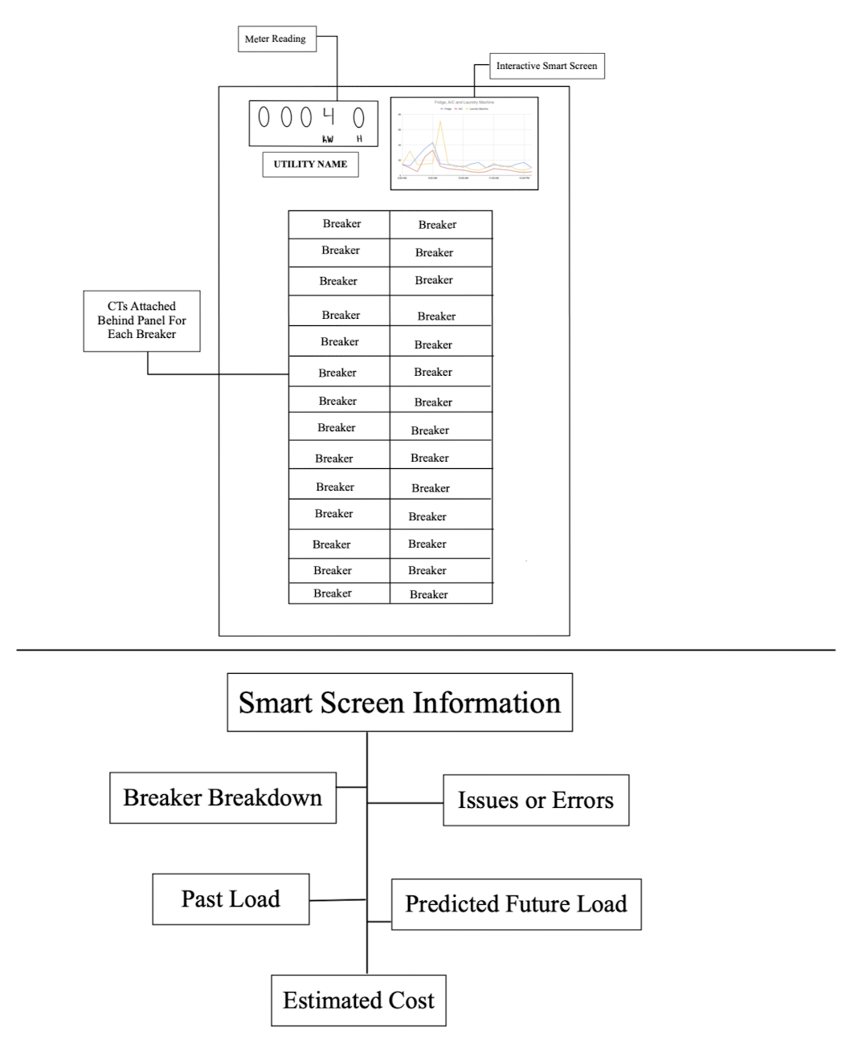

## Concept Differences Table and Mockup Demo Preparation:

| **Concept #:** | **Concept 1** | **Concept 2** | **Concept 3** | **Concept 4** |
| --- | --- | --- | --- | --- |
| Concept: | CTs on main leads and device in residential panel | Device gathers power usage data from meter | CTs on every branch, remote thermostat outside | Replace entire panel with smart panel |
| Difference 1  (Measuring Power) | 2 current transformers would be installed on the incoming feeders | Device would sit on top of meter and receive measurements | Up to 20 CTs would be installed, one on each branch | Each breaker would have a built in CT |
| Difference 2  (Data Processing) | Machine learning would be used to disaggregate signals | Machine learning would be used to disaggregate signals | Data would be measured separately, already disaggregated | Data would be measured separately, already disaggregated |
| Difference 3  (Weather) | Weather would be pulled from an online source | Real time weather data could be collected from the main device | Real time weather data could be collected from a secondary device | Weather would be pulled from an online source |
| Difference 4  (Accuracy) | Less hardware accuracy, dependent on machine learning | Less hardware accuracy, dependent on machine learning | Very accurate hardware, no machine learning dependency | Very accurate hardware, no machine learning dependency |
| Difference 5  (Installation) | Only a few connections to make inside panel | No connections to make, just place on meter | Many connections to make inside the panel | Difficult install process, complete replacement of panel |
| Difference 6  (Cost) | Inexpensive | Very inexpensive | Expensive | Very expensive |
| Making of the concept Mockup | Concept prototype would require CTs and development board | Concept prototype would require communication with existing power meter | Concept prototype would require many CTs and a development board | Concept prototype would require smart circuit breakers and an MCU for communication |

Table 1: Concept differences

# User Operational Flow Chart:

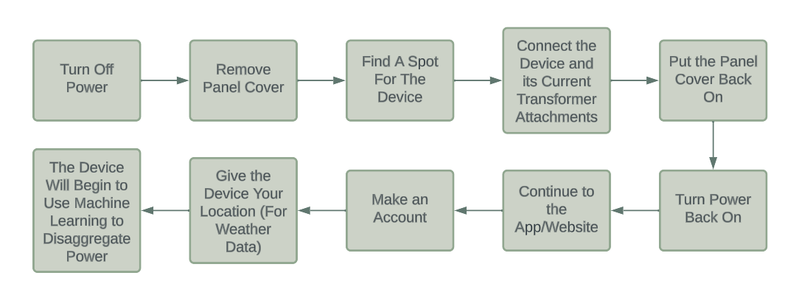

# System Functional Block Diagram:



# Table of Trade-offs:

|  | *Concept 1* | *Concept 2* | *Concept 3* | *Concept 4* |
| --- | --- | --- | --- | --- |
| Key Requirements/Criteria | CTs on main leads and device in residential panel | Device gathers power usage data from meter | CTs on every branch, remote thermostat outside | Replace entire panel with smart panel |
| *Feasibility* | Easy to prototype and manufacture | Accessing smart meters owned by utility may be difficult | Easy to prototype and manufacture | Very difficult to prototype and manufacture |
| *Durability* | Device would not have to withstand harsh conditions since it is inside | Device would have to withstand harsh outdoor conditions | Device would not have to withstand harsh conditions since it is inside | Device would not have to withstand harsh conditions since it is inside |
| *Ease of use* | Usage would be completely online after installation | Usage would be completely online after installation | Usage would be completely online after installation | Usage would be completely online after installation |
| *Disaggregating Data* | Machine learning software would be used | Machine learning software would be used | Separate measurements made with hardware | Separate measurements made with hardware |
| *Installation* | Installation would require adding CTs inside in the breaker panel | Installation would require mounting a device on the meter outside | Installation would require adding CTs inside in the breaker panel | Installation would require replacing the current panel |
| *Cost* | Final cost for the product should be no more than $100 | Final cost for the product should be no more than $100 | Predicting a higher cost, around $300, as more CT connections used | Costs predicted to be more than $1000, as complete replacement of panel will take place. |
| *Technical support* | Help with installation could be provided with the website. | Technical support with installation could be provided by the utility company that owns the meter | Help with installation could be provided with the website. | Help with installation could be provided with the website. |
| *Overall Evaluation* | The ease of use and satisfactory cost makes it appropriate for most consumers. | The ease of use and cost are good, but reliance on the utility company is an issue. | The cost of this design makes it an unrealistic option for most consumers. | The extreme cost of this design makes it an unrealistic option for most consumers. |

# 

# Design Challenges:

* Communicating data between the device and our online storage
* Accurately measuring weather conditions
* Supplying power to device
* Creating a machine learning based algorithm to detect devices
* Using machine learning algorithms to disaggregate the devices to detect what is what
* Ensuring that data is sent quickly as to maintain a steady flow of data to our application
* Displaying an easy to use and informative user interface
* Predicting future load usage may be tricky because it will depend on the accuracy of our disaggregated data

# First Technical Milestone Preparation (“Hello World” demos):

| **Identified Technology/Tool** | **Project purpose** | **Specific ways of getting up to speed/help needed** | **“Hello World” demo** |
| --- | --- | --- | --- |
| CT Board and ESP32 | Gather data from residential panel | Reference manufacturer of CT board | Receive local measurements from board |
| ESP32 MCU | Send data from device over WiFi to a google sheet | Reference communication standards and datasheet for ESP | Transmit data from device over WiFi |
| Google Sheets | Hold and display data (power and weather) in graphical form | Learning how Google Sheets communicates with outside sources | Sheet displaying power usage vs. time and weather |

# Long-lead-time or critical items for purchasing*:*

* At the moment we have not identified any purchasing needs for our project. We may need to purchase items in the future if we desire to upgrade or manipulate the hardware from the former group's project, but at the moment we do not have any purchasing needs.